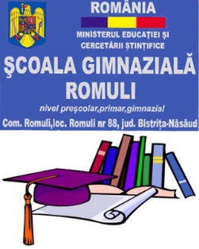
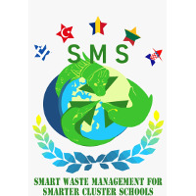
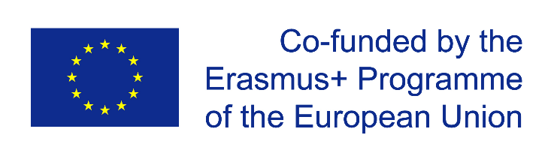

ERASMUS PROJECT: Smart Waste Management for Smarter Cluster Schools
PROJECT NUMBER: 2020-1-RO01-KA229-079971_5
DATE: 4^{th-} 8th of April 2022
Host: Romuli Secondary School
Number of participants: 25 students, 10 teachers
Event: short-term exchange of groups of pupils
Mobility title: Reduce! Efficient use of resourcing for preserving the planet heritage - ROMANIA 2
MOBILITY FEEDBACK REPORT
The mobility in Romuli has completed according to the host’s and the guests’ expectations. 31 students and 12 teachers
The aims of the activities were the following:
1) gaining participator methodolgy, based on discovering, exploring and collaboration;
2) experiencing the process of efficient use of resourcing for preserving the natural heritage, using active learning methods;
3) increasing the participants’ knowledge in terms of efficient use of natural resources
4) learning new strategies for recycling waste;
5) gaining information regarding the importance of protected species, their natural habitat and nature reserves;
6) becoming more conscious regarding the significance of enviornmental protection and smart waste management;

By the end of the mobility, the participants were sent an online feedback questionnaire in Wordwall, in which they had to express their opinion related to the points 1-6 from above, by choosing 1 of 3 possible answers: agree/partly agree/disagree.

According to the results...

- 95% of the participants selected agree and 5% were partly agree with the first statement – I have gained participator methodolgy, based on discovering, exploring and collaboration
- 98% of the participants agreed with I experienced the process of efficient use of resourcing for preserving the natural heritage, using active learning methods, while 2% agreed partially
- 87% of the participants agreed they had increased their knowledge in terms of efficient use of natural resources,while 13% chose partly agree
- 99% of the participants agreed they had learned new strategies for recycling waste, 1% selected partly agree
- 100% of the participants agreed they had gained information regarding the importance of protected species, their natural habitat and nature reserves
- 99% of the participants agreed they had become more conscious regarding the significance of enviornmental protection and smart waste management and 1% selected partly agree

Conclusions
According to the participants general impressions and face to face given opinions, the feedback questionnaire and the coordinator’s vision...
- the objectives of the mobility were reached
- the mobility programme was clearly and impeccably implemented
- the mobility was very well organized and it developed according to the expectations
- the participants explored and collaborated in order to experience the proces of efficient use of resourcing of preserving the planet heritage
- the natural resources system has been clearly presented and understood
- new strategies of recycling waste have been implemented
- significant words related to environmental issues like protected species, natural habitat, drought, scarcity, conservation have been debated and assimilated
- the consciousness regarding the importance of smart waste management and environmental protection have been largly acknowledged

